**Assignments 1 ADTA 5560 Recurrent Neural Networks for Sequence Data**

**Yog Chaudhary**

**11727095**

ADTA 5560 Recurrent Neural Networks for Sequence Data

Professor: **Dr. Thuan L Nguyen**

University of North Texas **Sep 23, 2024**

**1. PART I: Confirm UNT Student Email Address (10 Points)**

* 1. What is the student’s UNT student email address (…@my.unt.edu)?
* **YogChaudhary@my.unt.edu**
  1. Has the student received the Welcome-to-the-Class message via his/her email?
* **Yes, I did** 
  1. If NO to Question 1.2, can the student access the student email (…@my.unt.edu)?
* **N/A** 
  1. Is the student a UNT employee?
* **N/A** 
  1. If YES to Question 1.4, does he/she prefer using the UNT employee email for class communication?
* **N/A**

1.6 If YES to Question 1.5, what is the student’s UNT employee email?

* **N/A**

**2. PART II: Select an Operating System (10 Points)**

I will be using Windows as an OS for this course, and good knowledge of drive, directions and folders, files, the ownership status of these components, and administrative privileges. I can create new folders, access existing ones along with their actual contents, and create and save files within these folders. Download software applications, store them in specific folders, and install these applications in real, physical directories. Additionally, I can troubleshoot issues using various resources, such as online research, vendor support, and public technical forums. Therefore, I can use Windows effectively for cloud-based deep-learning tasks. Windows offers a user-friendly interface for all these actions, making it convenient for this course.

**3. PART III: Set Up Deep Learning Virtual Machine (VM) in GCP (20 Points)**

**3.1 We have successfully set up a remote on Google Cloud (GCP) by the following steps.**

* Click on open GCP
* Click on the free Trail
* Enable computing engine**.**

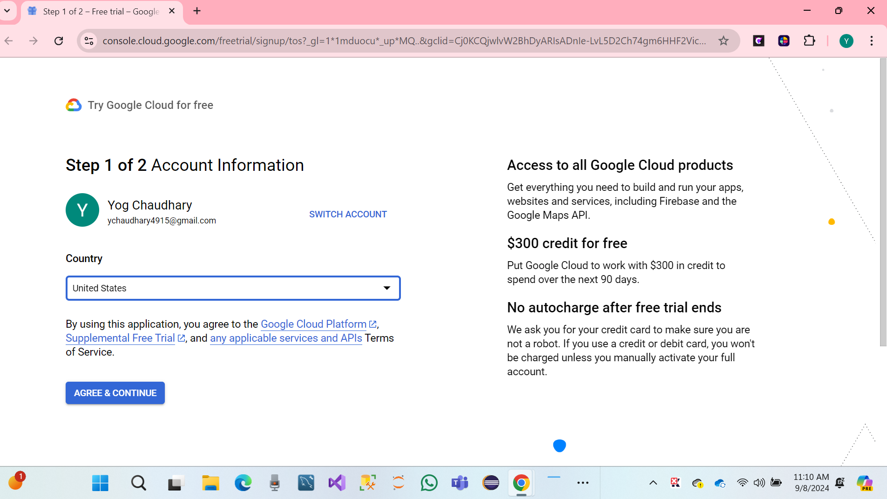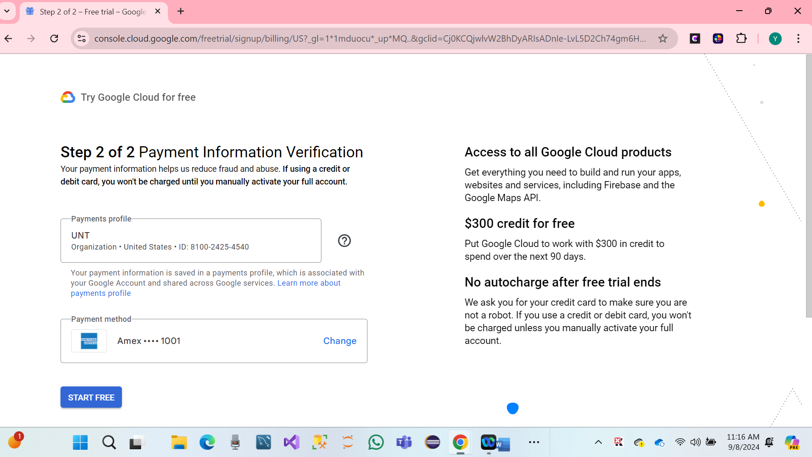

* Click on Activate and continue.

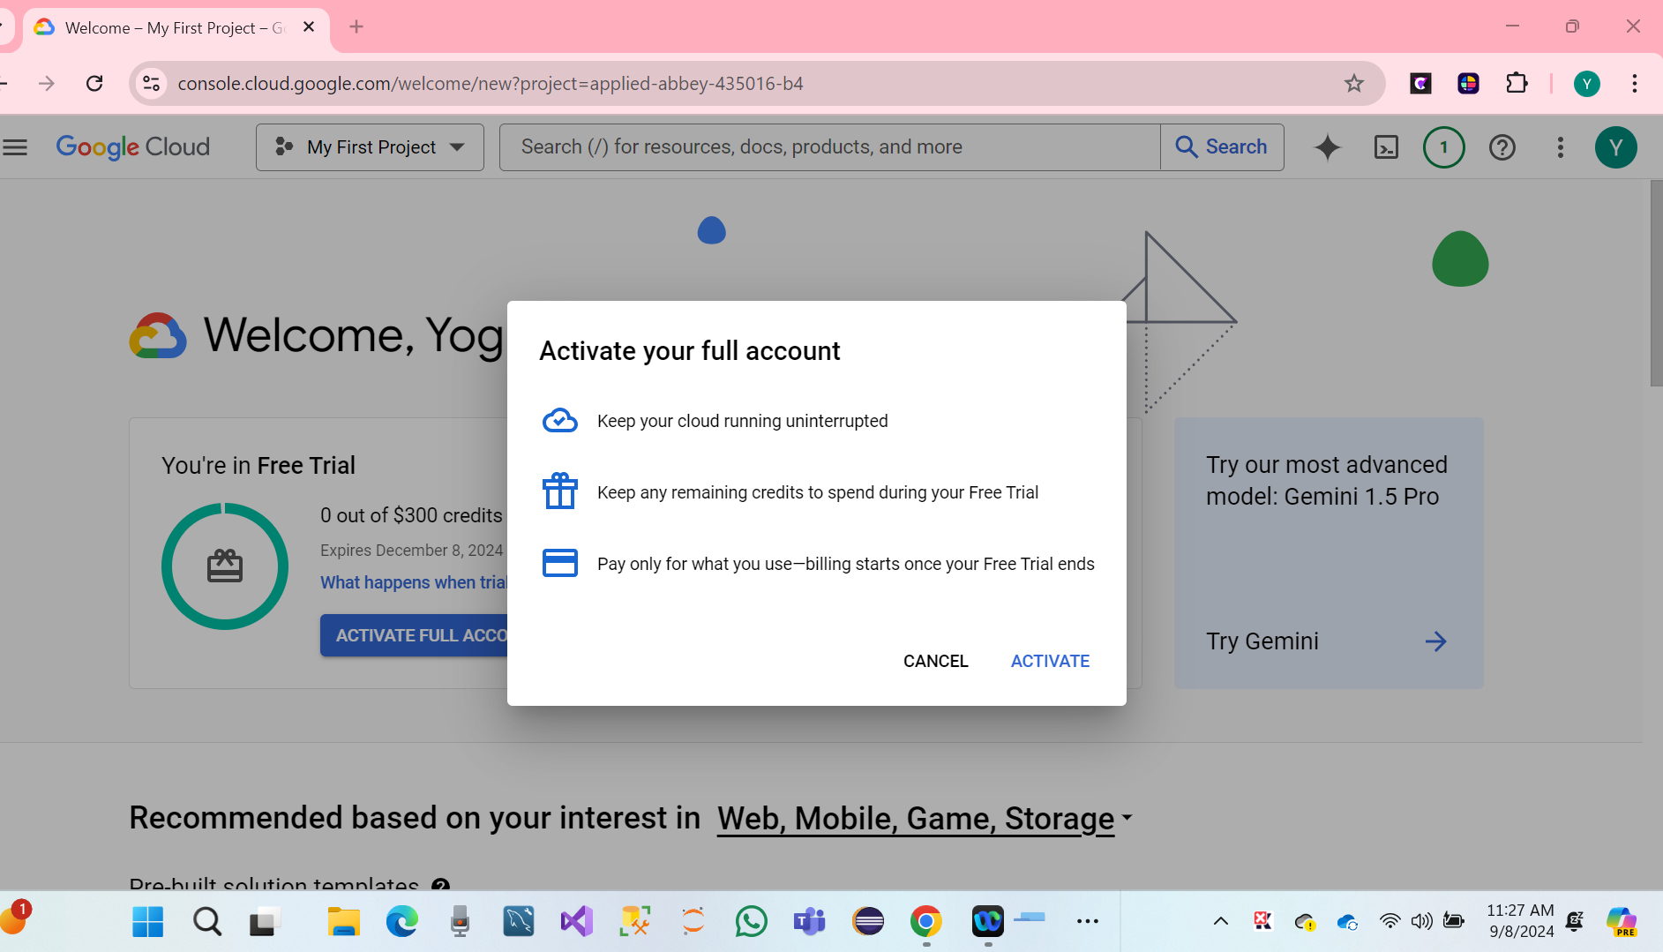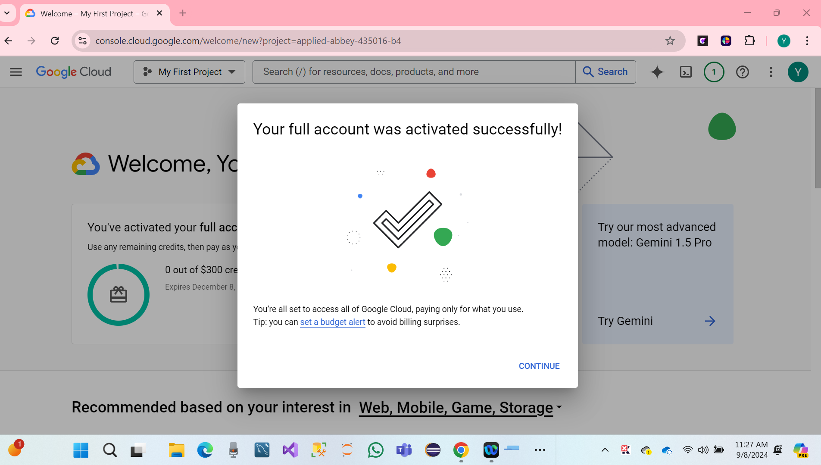

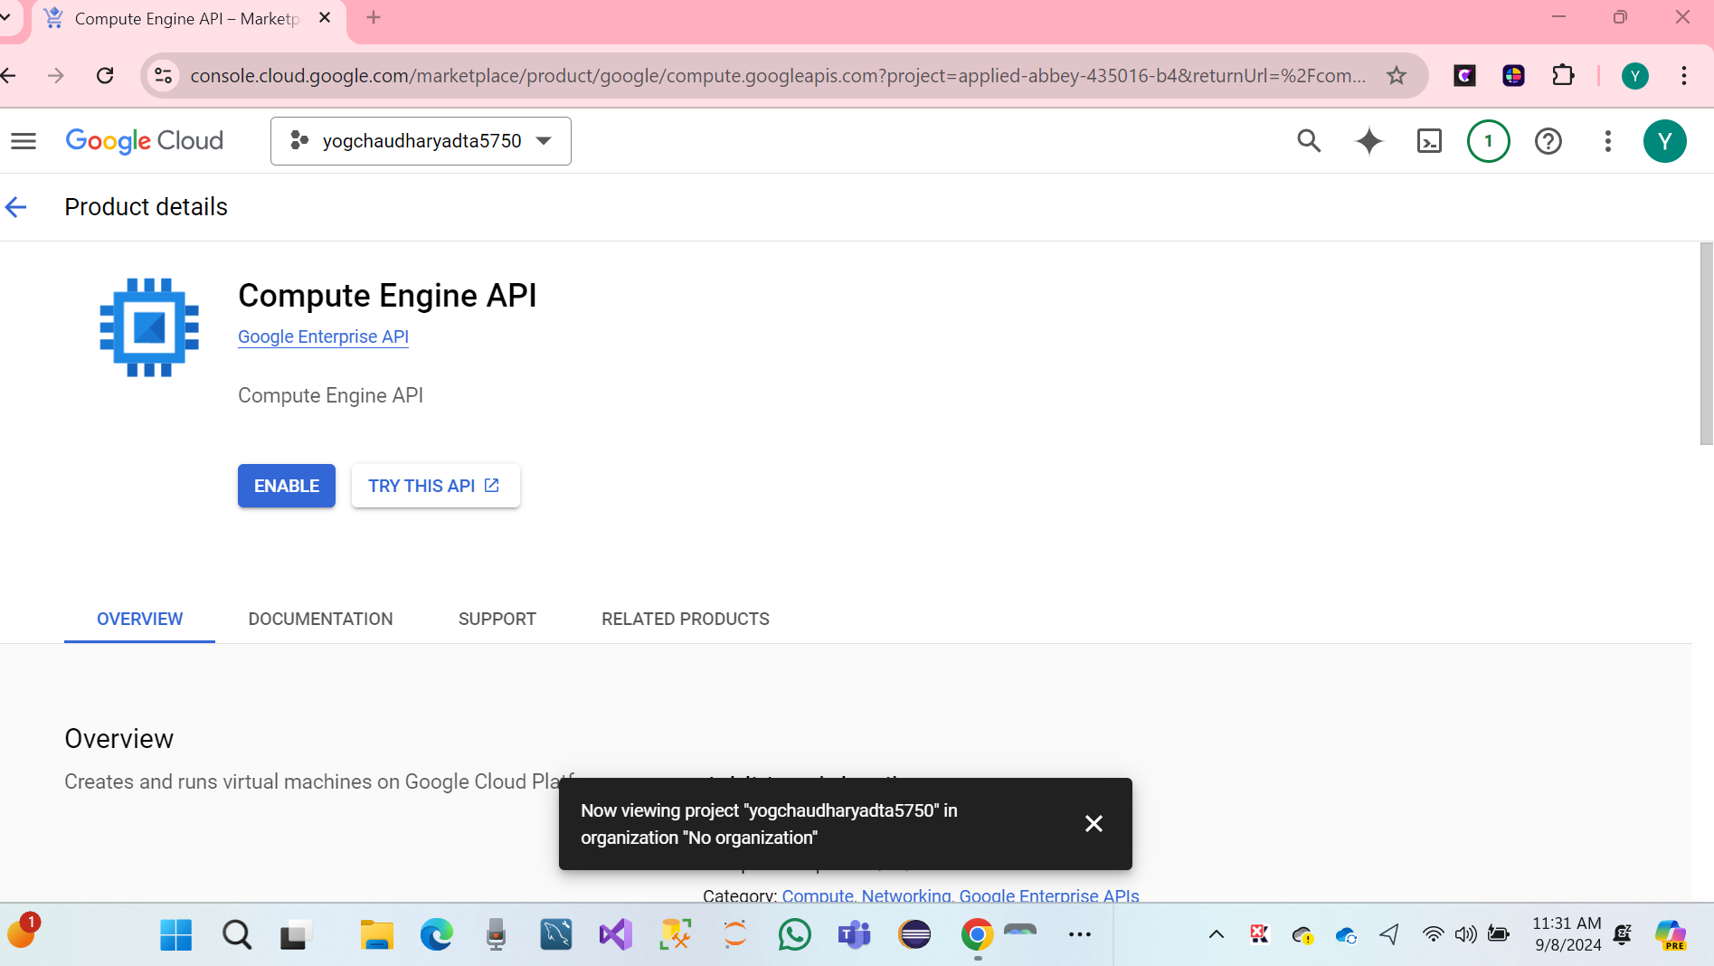

* Click on Enable computer engine.

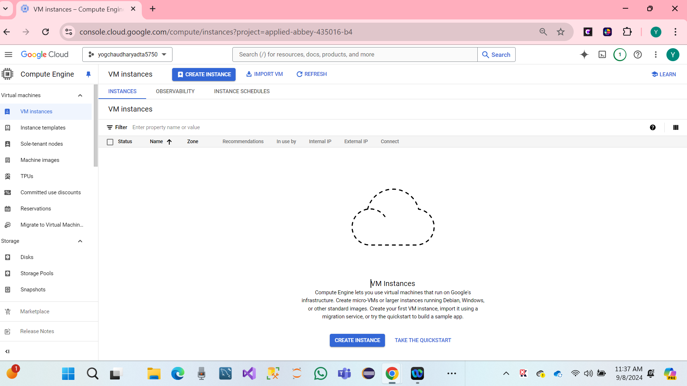

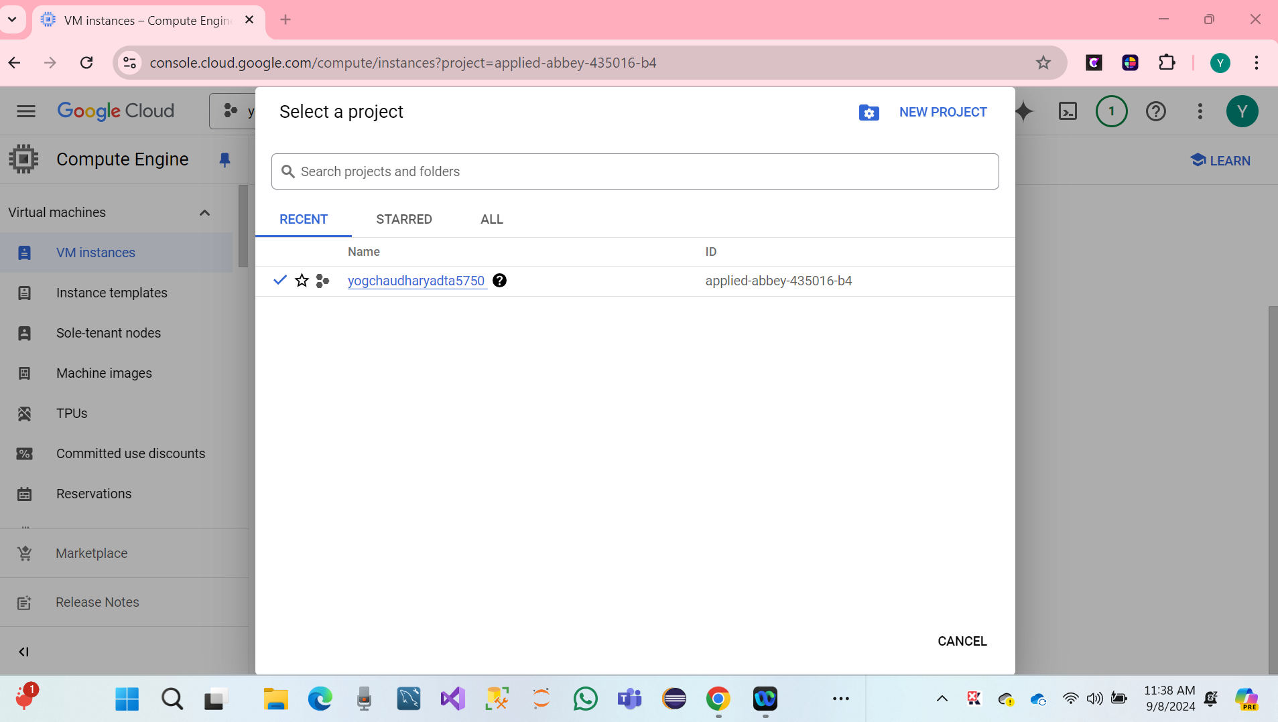

We have created **VM Instances**.

* Click on the search bar and click on cloud shell
* Click on Continue.
* Create Deep Learning VM Using GCP Deep Learning Image.
* Cloud Deep Learning VM Image.
  1. **We have Set Up Remote Deep Learning Server in GCP**
* **Click on link:** [**https://cloud.google.com/deep-learning-vm/**](https://cloud.google.com/deep-learning-vm/)

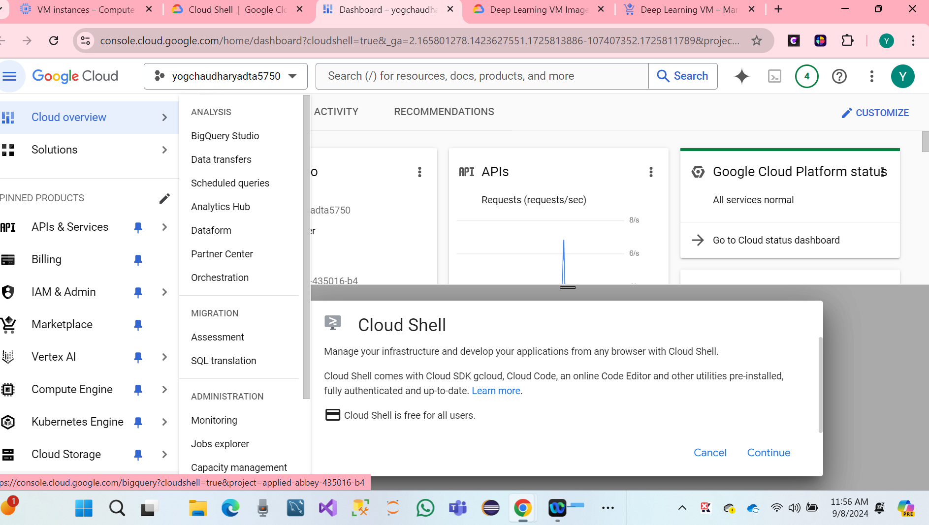

* Click on cloud shell to continue.

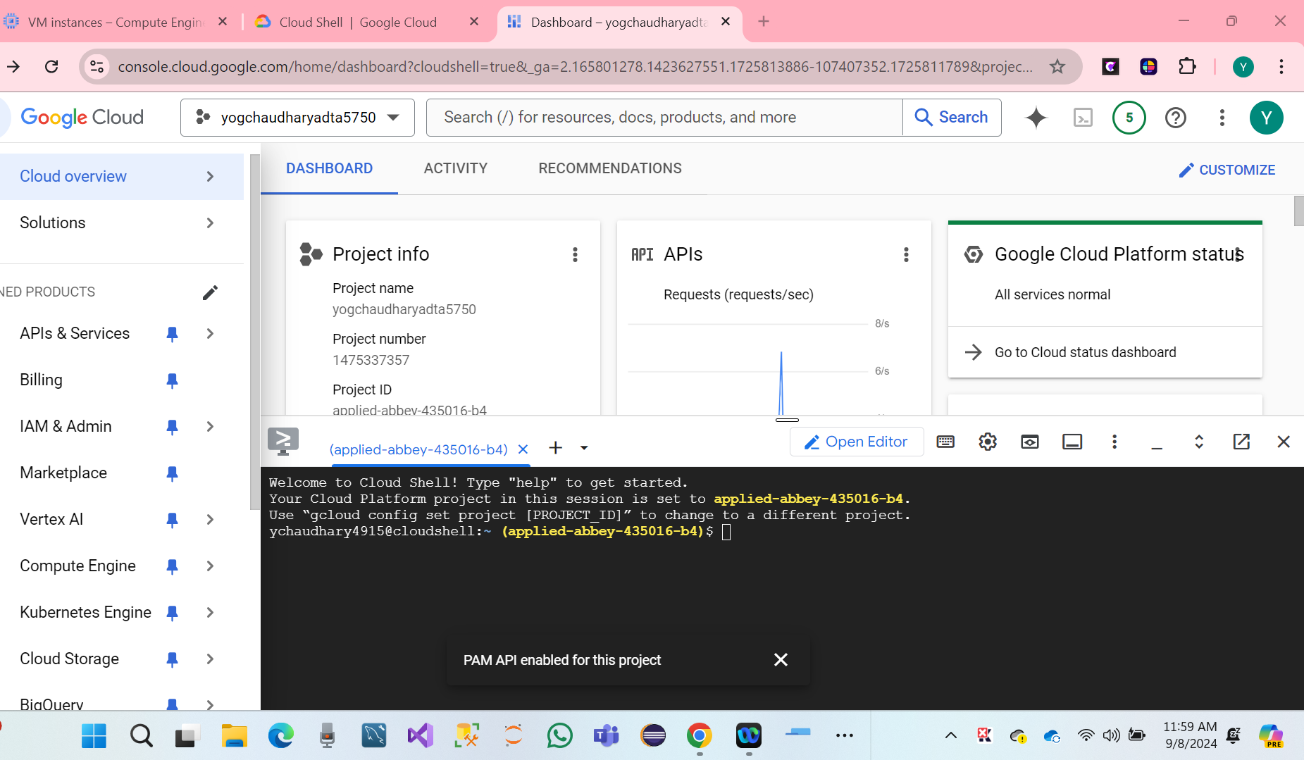

* We have a Drag tab to a new window.
* Open the cloud shell and copy and paste the code below.

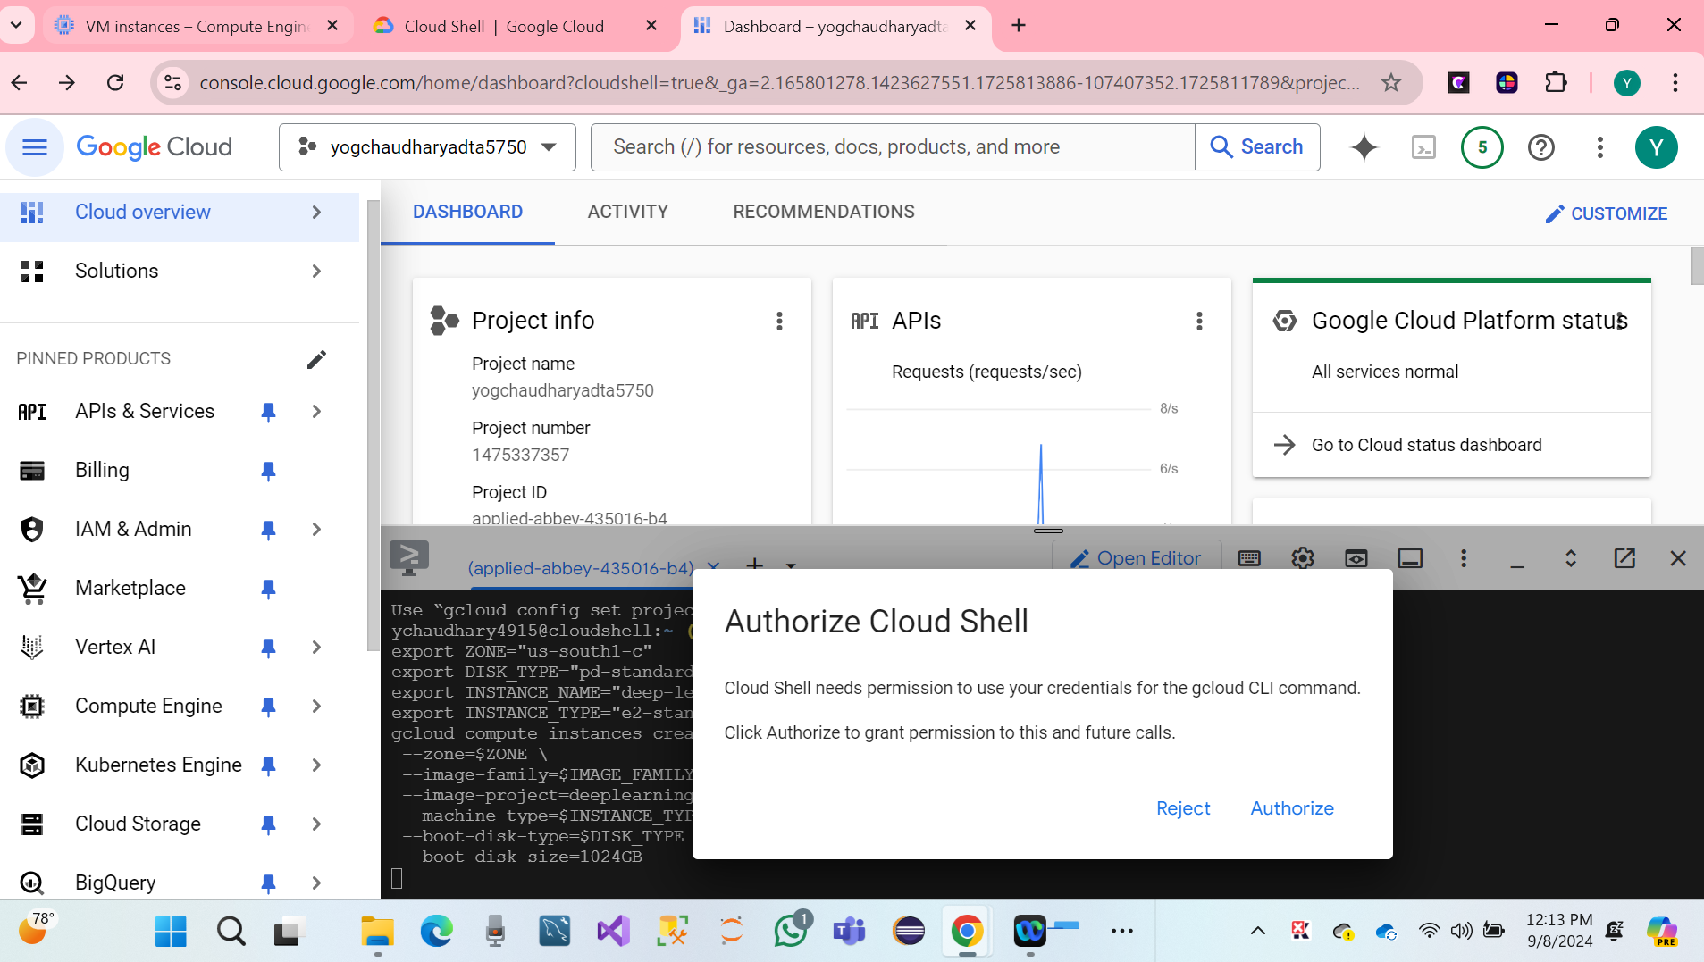

* We have to click on Cloud Shell Authorized.
* Hare we, our search bar showing Deep Learning console.
* Name of VM Instance **tf2-keras-ann-vm**
* Hare Screenshot.

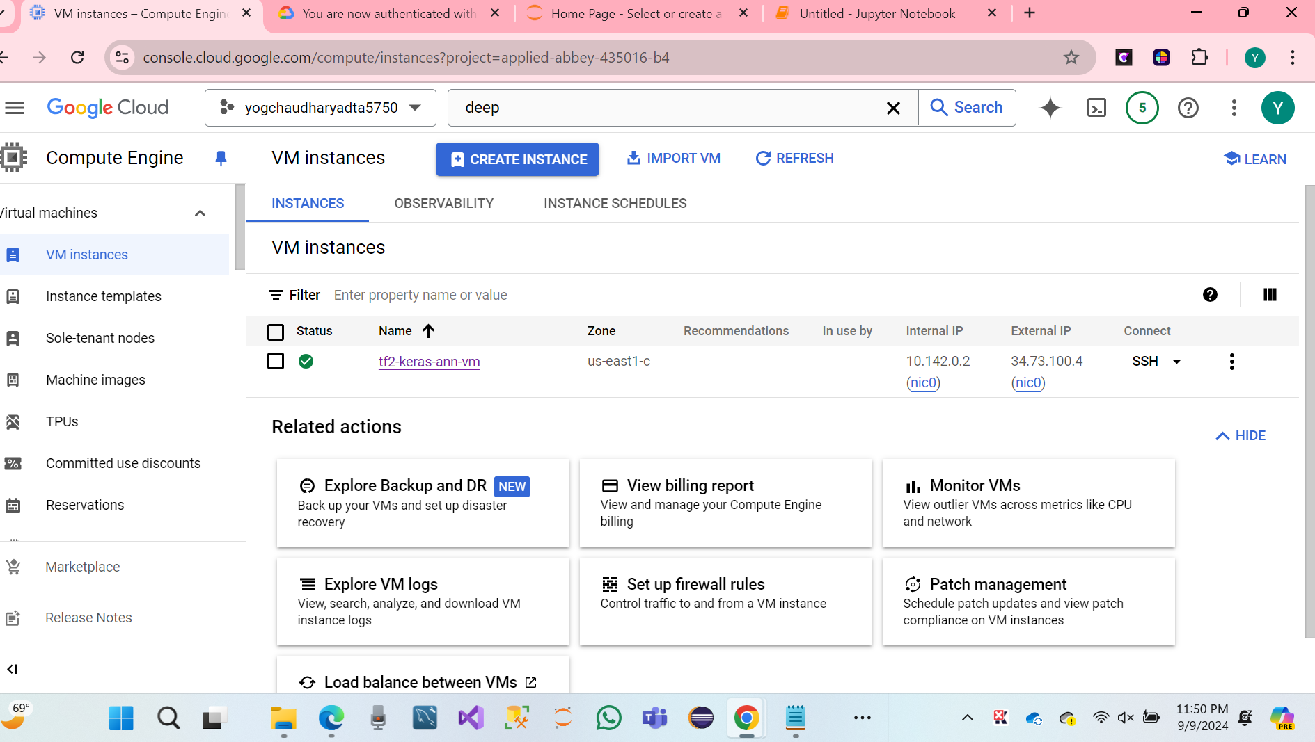

* Verify the TensorFlow Enterprises version of the VM Image.

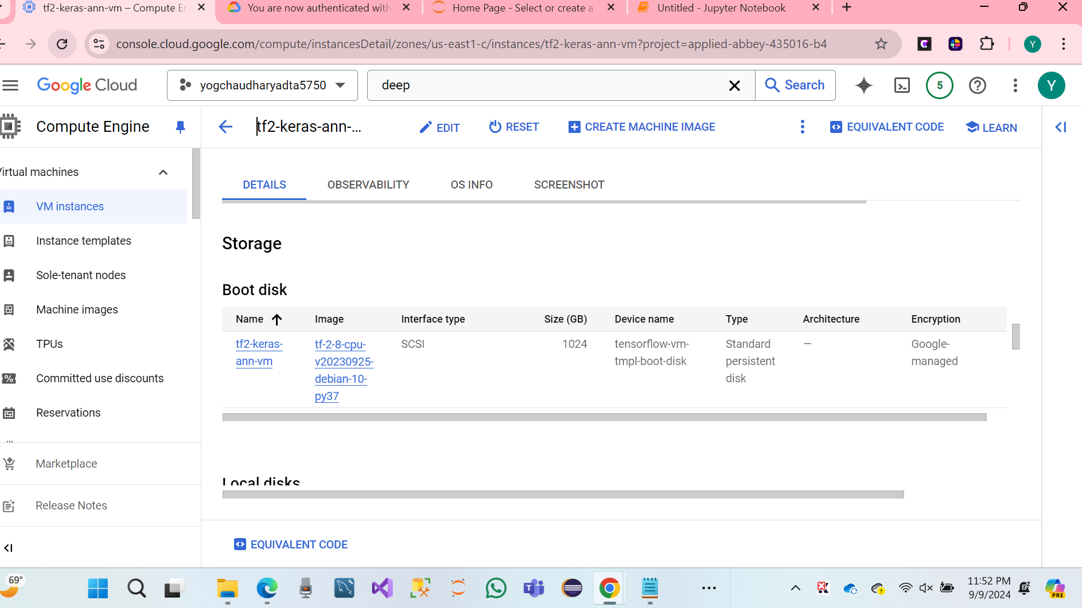

* **Deep Learning VM on GCP has been set up successfully**.
* **Access GCP Remote VM Console.**

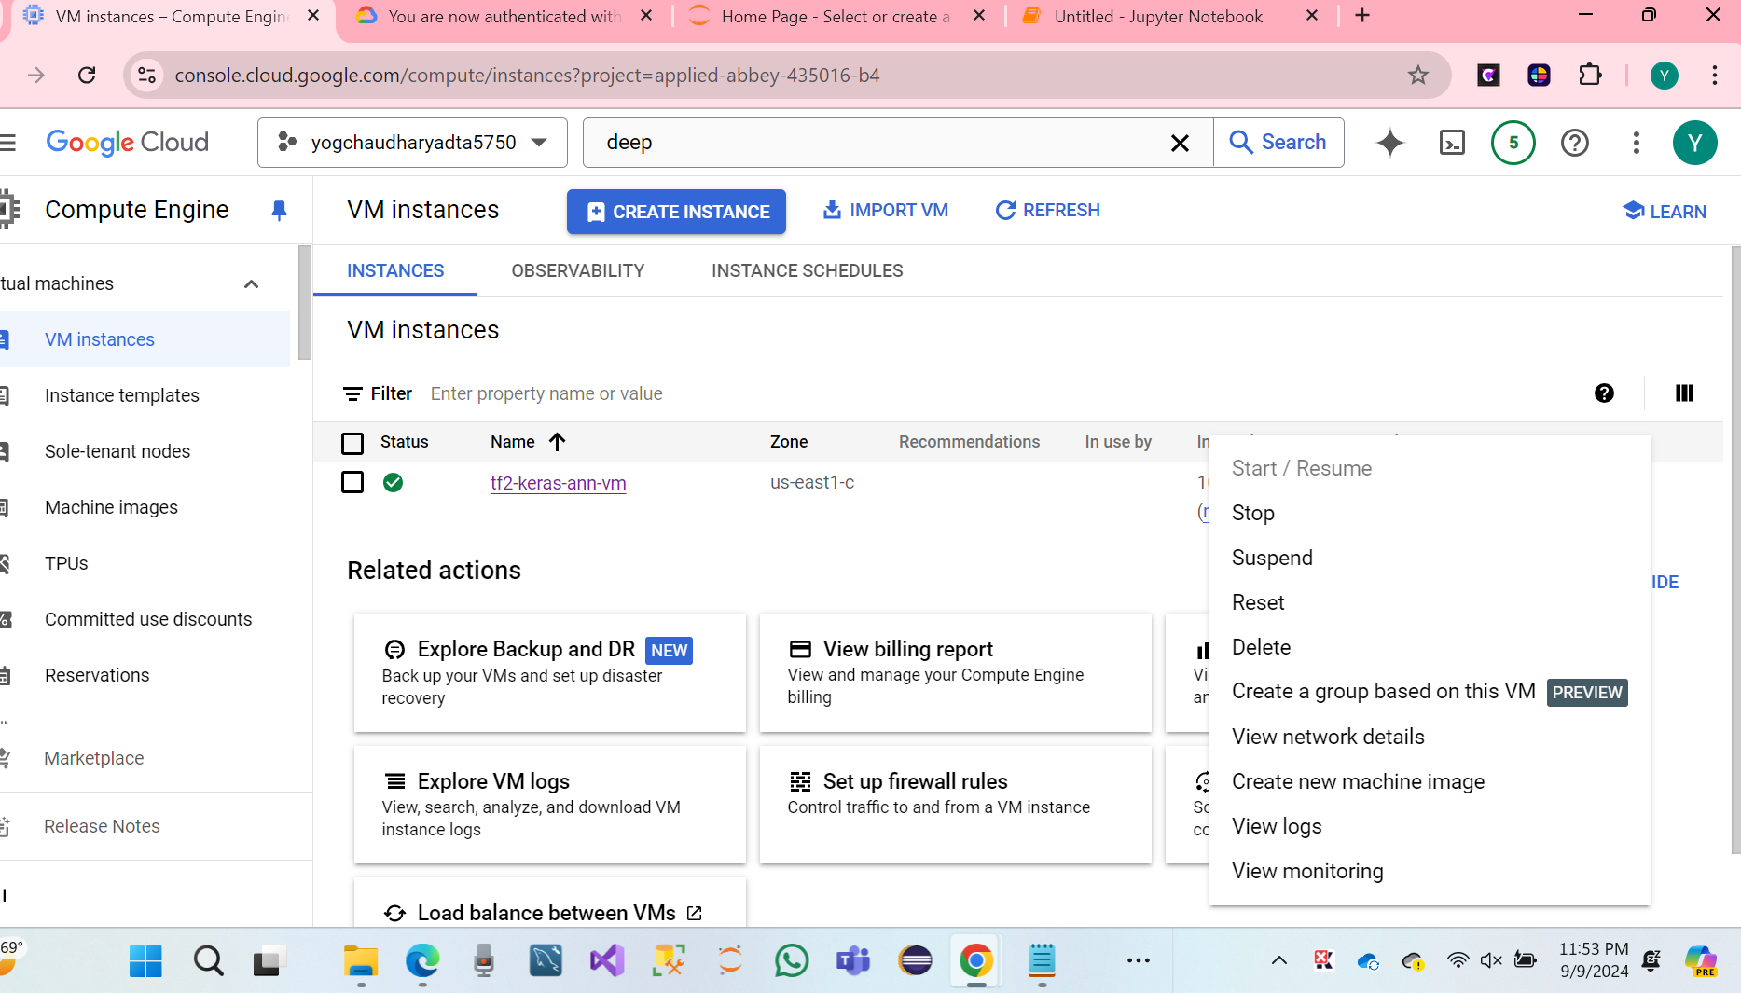

Note: Stop it when not Using.

**Install GCLOUD SDK**

* Click on the link: Download.

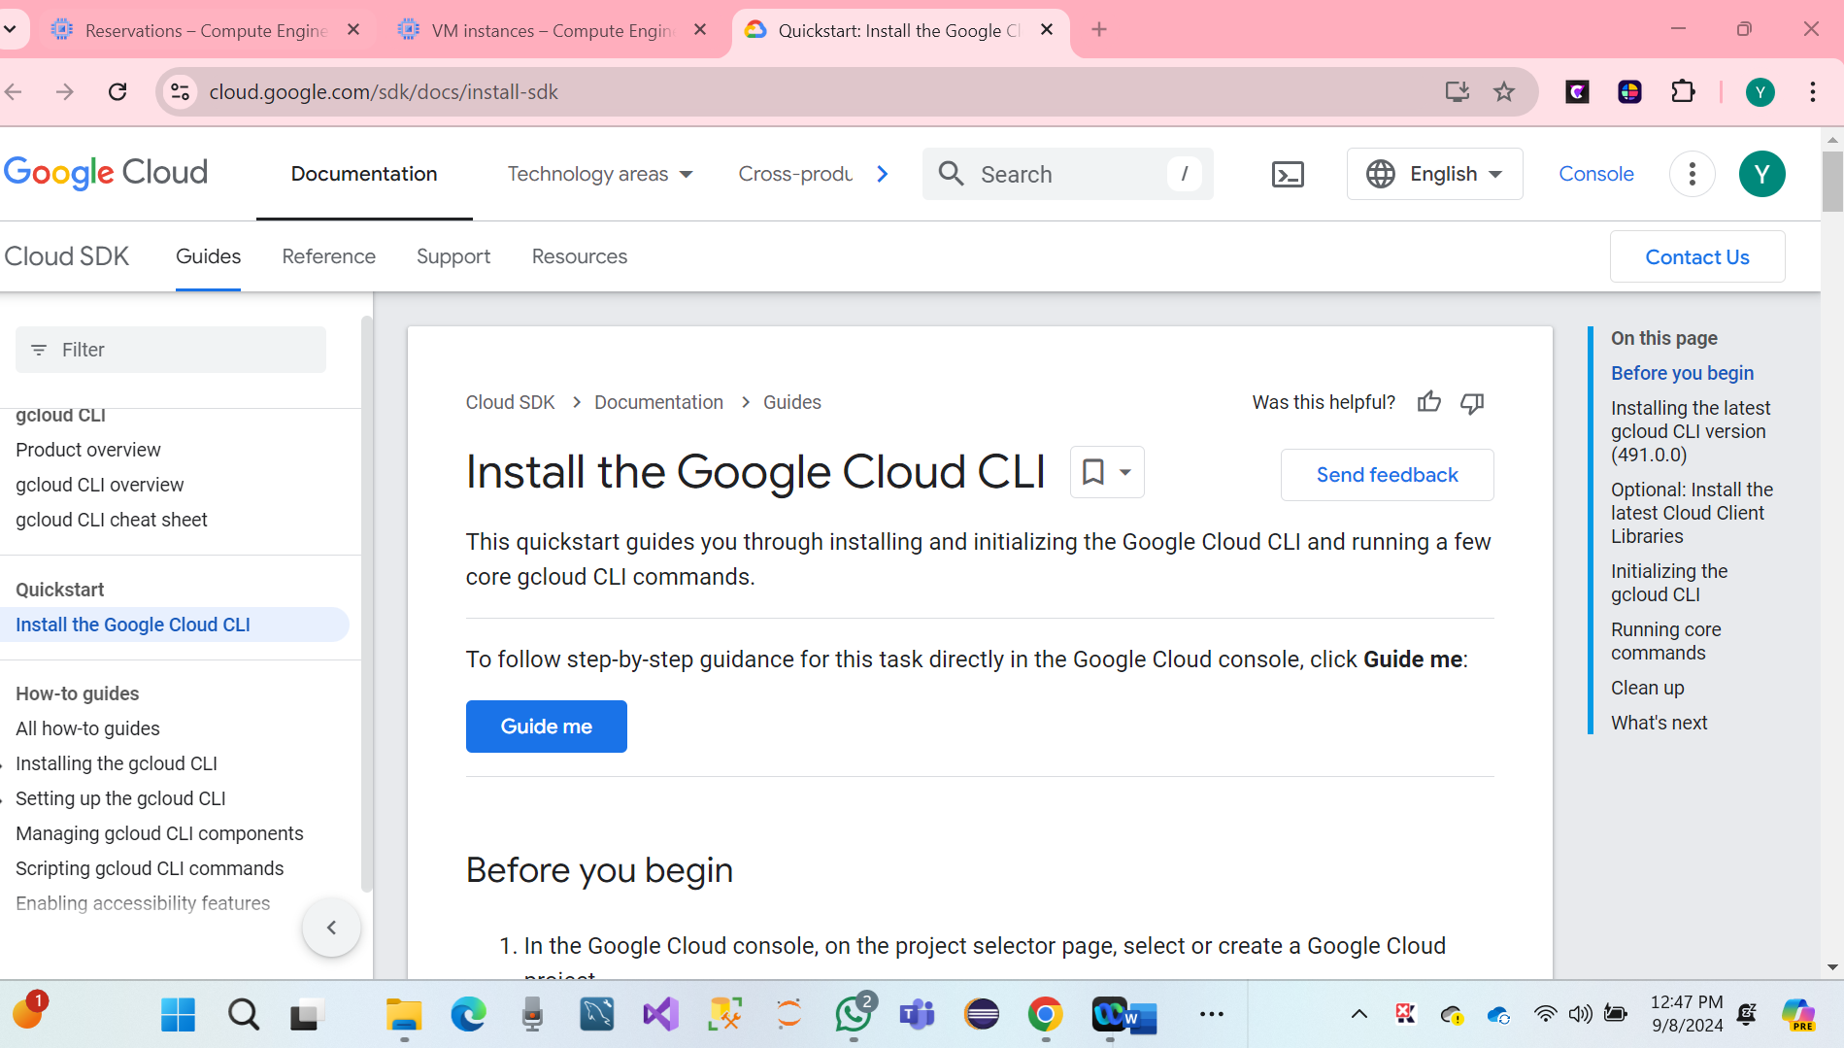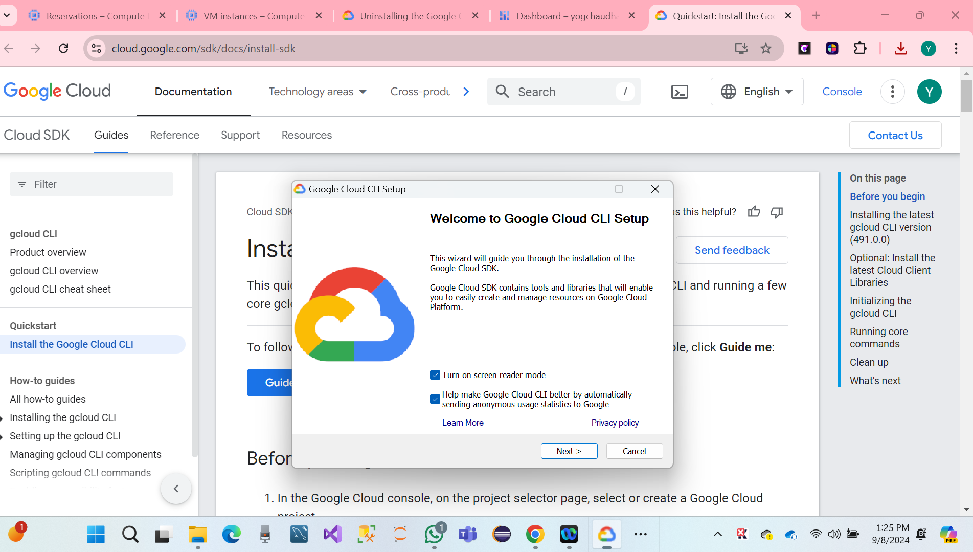

* We have to do a Finalize SDK Setting.

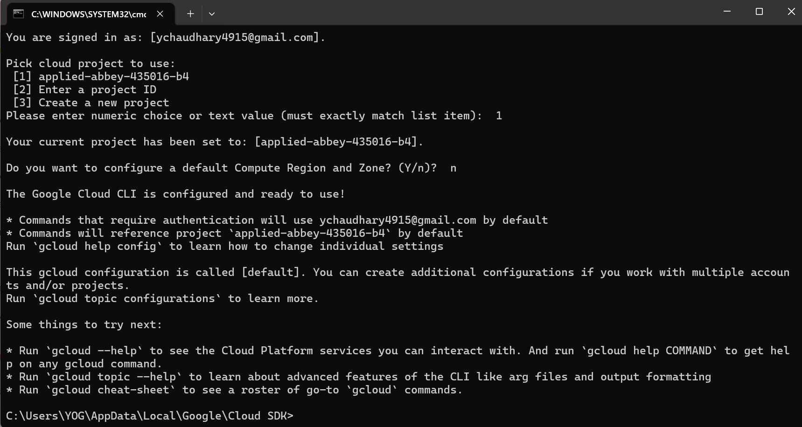

**Finally, GCLOUD SDK Has been successful.**

* Run GCCLOUD SDK Shell
* Hare Screenshot.

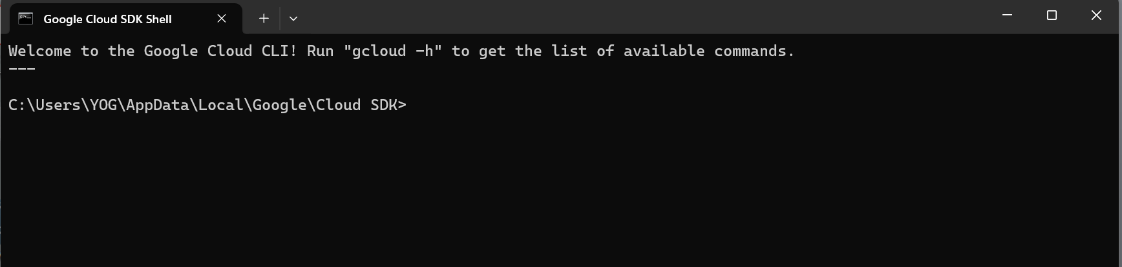

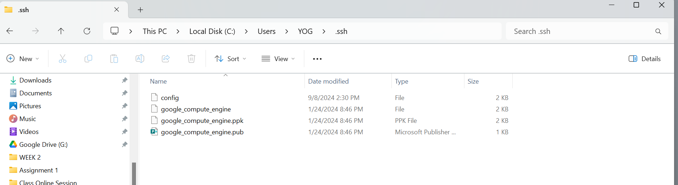

**4. PART IV: Connect Explore Remote VM Using SSH (10 Points)**

**Question 4.1:**

Based on the lectures, open an SSH connection from the local computer to the remote VM

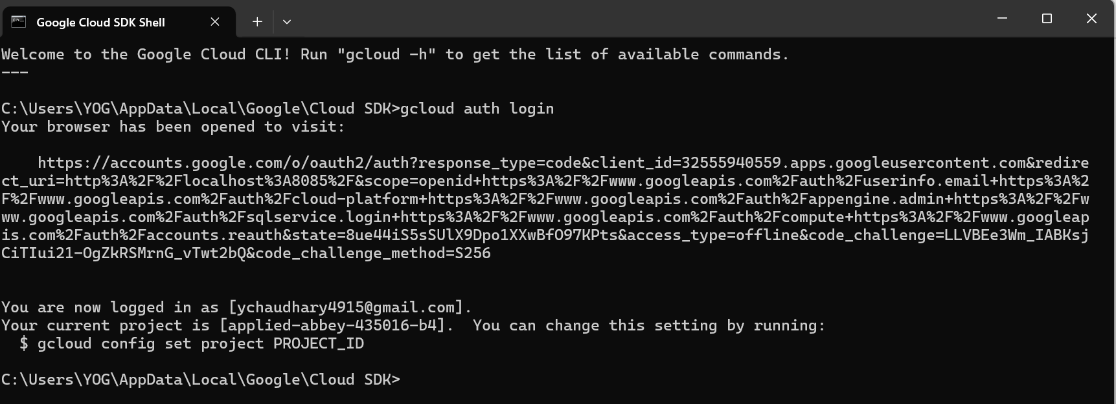

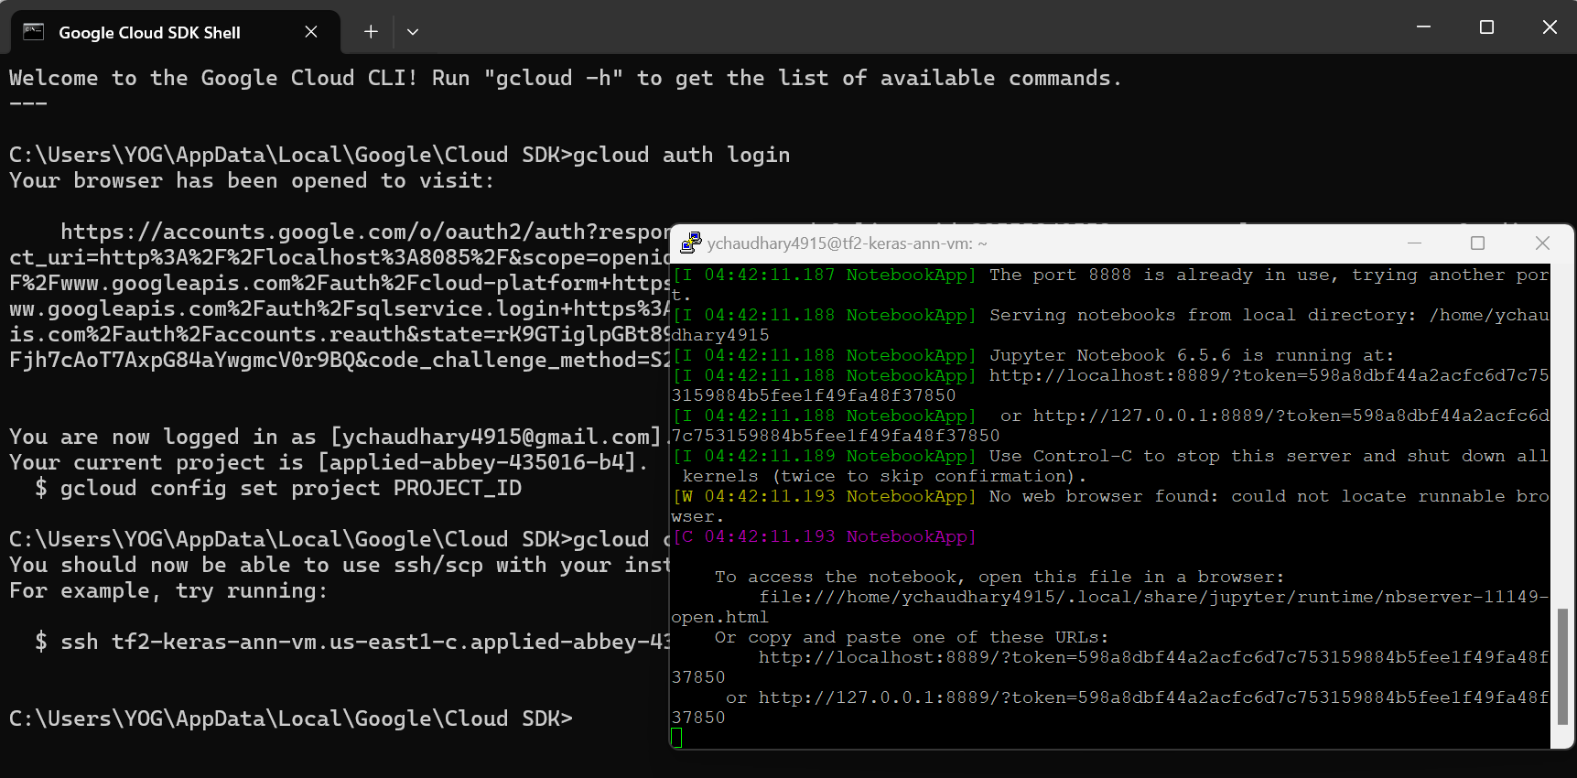

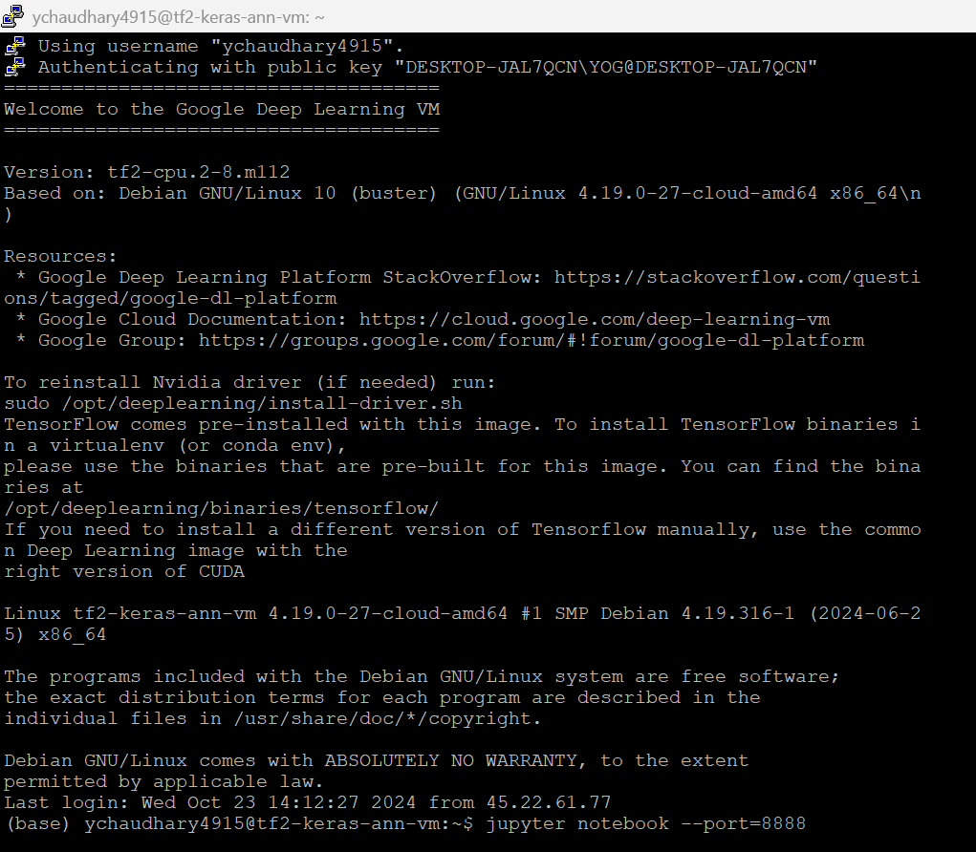

**Question 4.2**

Using the basic Linux command lines to explore the contents of the home directory

* Pwd
* whoami
* Ls -l
* Ls -all

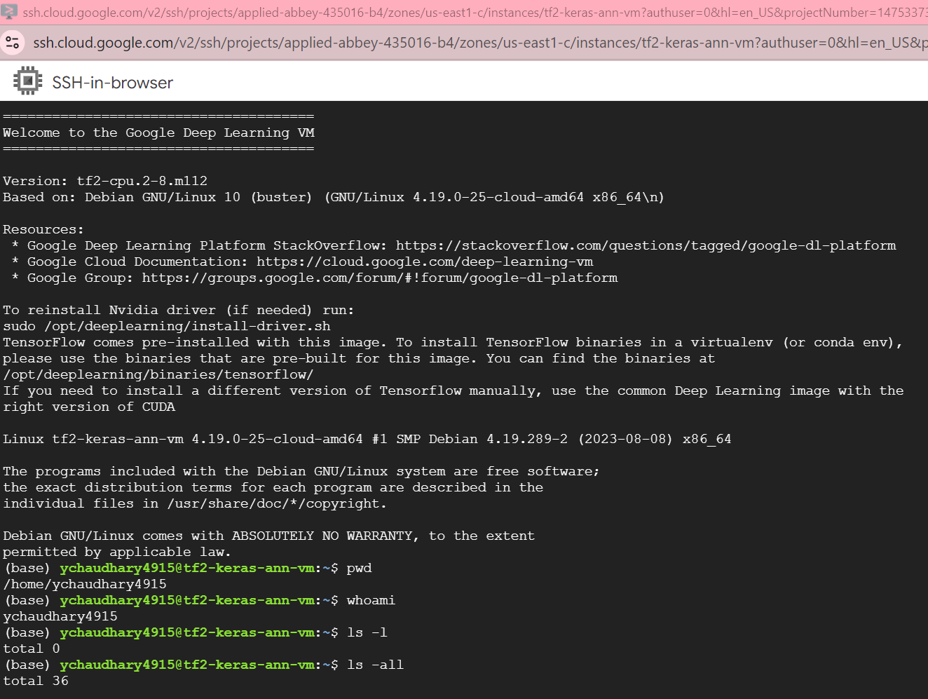

**Question 4.3**

Create a new sub-folder named “JPTR_NTBK” under the home directory

* Mkdir JPTR_NTBK
* Cd JPTR_NTBK

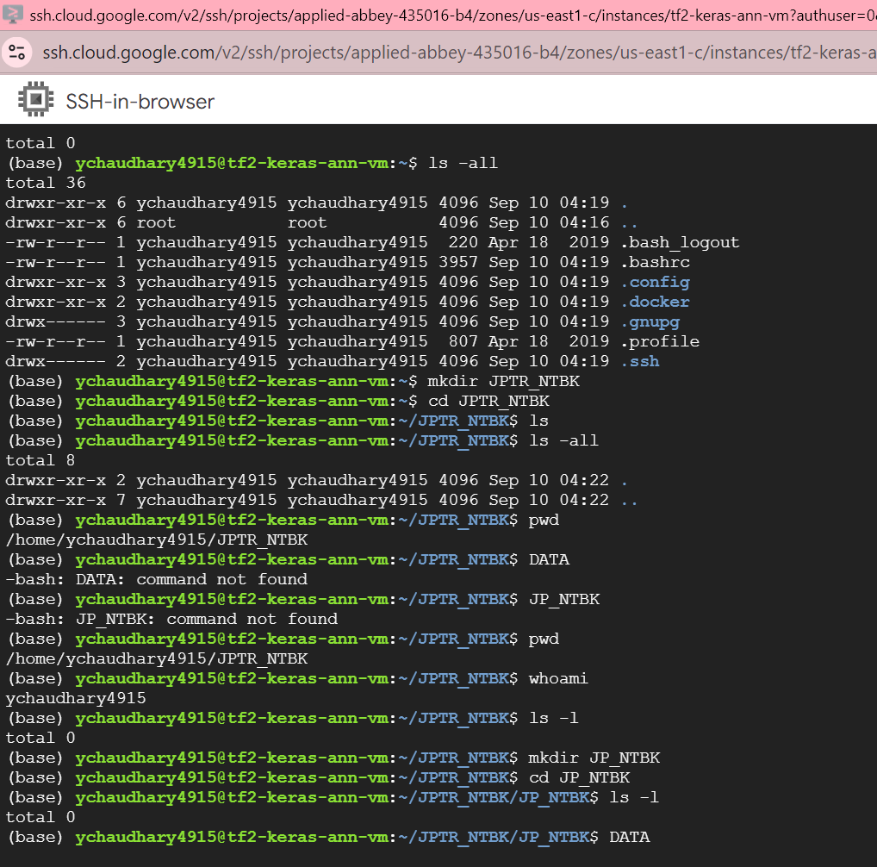

**Question 4.4**

Change the current directory to the newly created folder

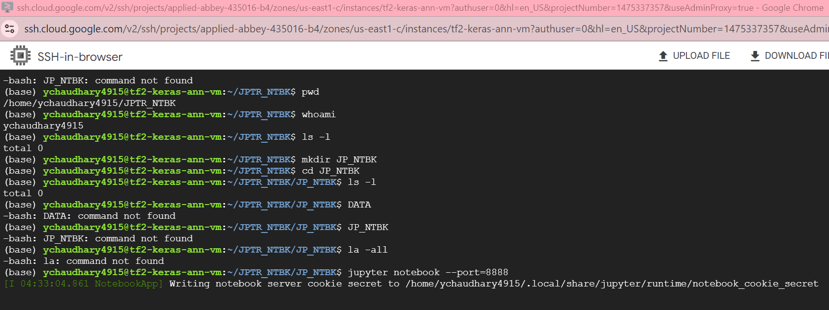

**5. PART V: Start and Connect to Jupyter Notebook in Remote VM (30 Points)**

**Question 5.1:**

Based on the lectures, start the Jupyter Notebook server in the remote virtual machine

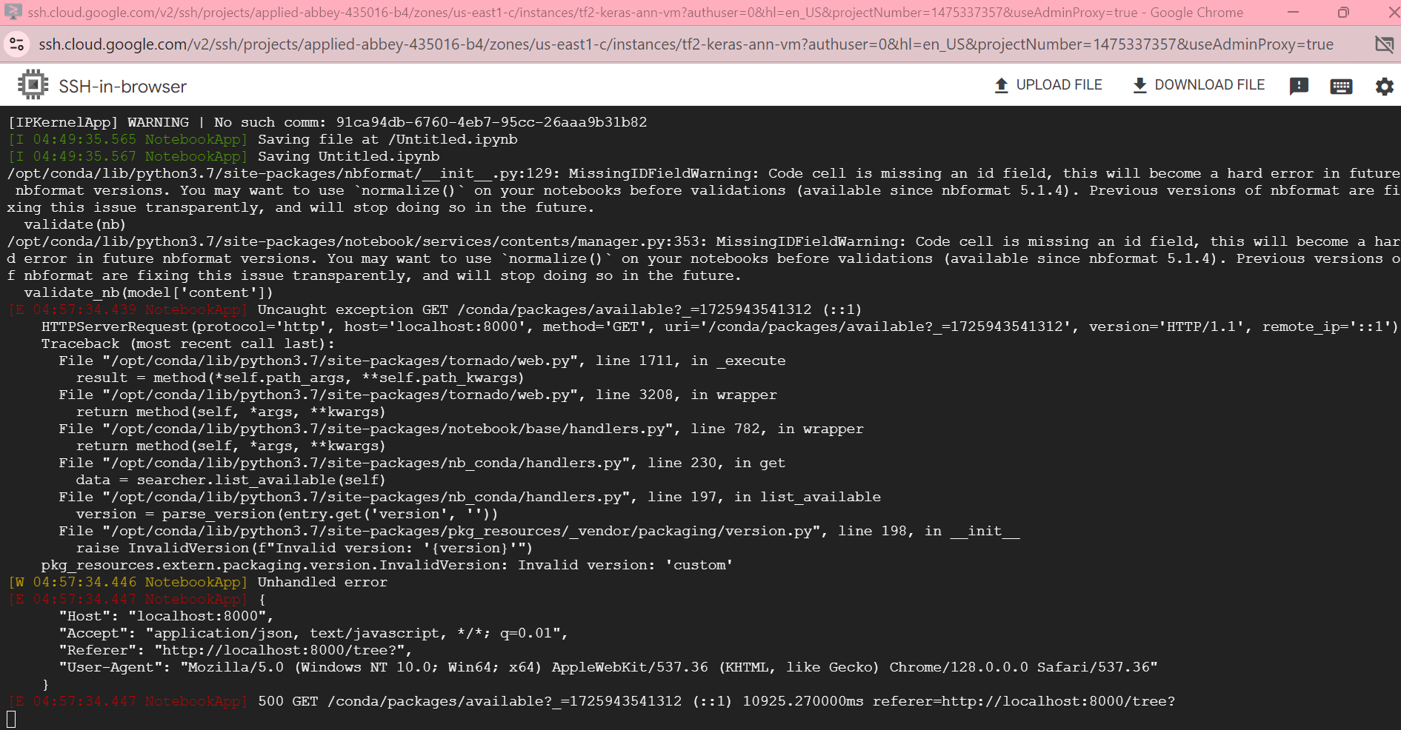

**Question 5.2:**

**gcloud compute ssh ychaudhary4915@tf2-keras-ann-vm --project applied-abbey-435016-b4 --zone us-east1-c -- -L 8000:localhost:8888**

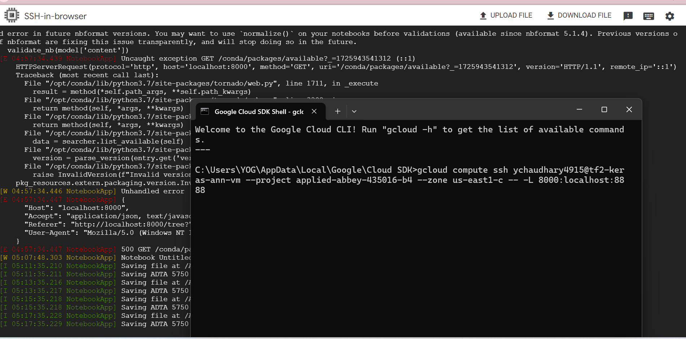

**Question 5.3:**

Use Jupyter Notebook that is currently running in the Remote Server (in a browser on the local computer).

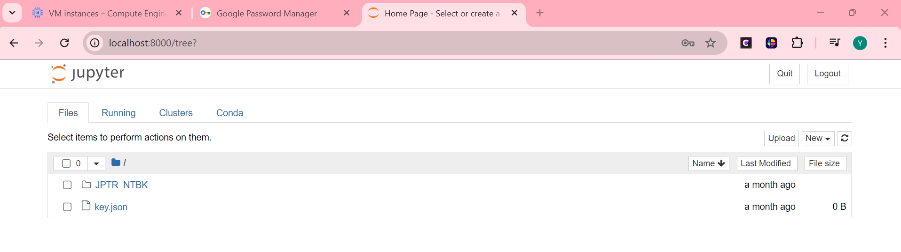

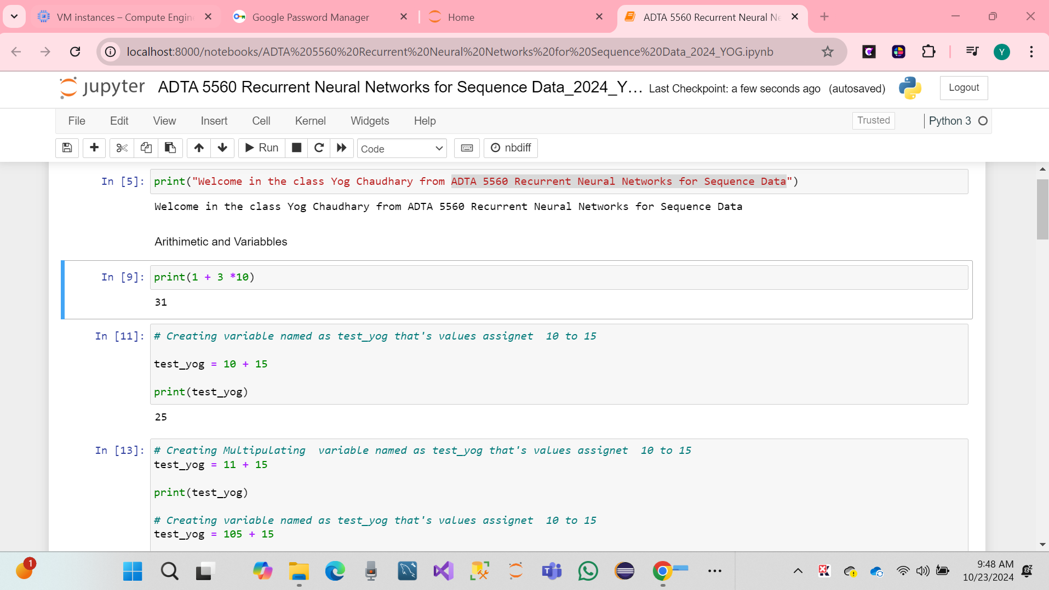

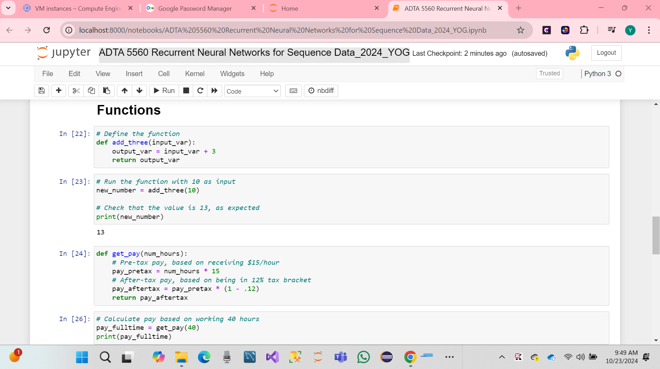

* Successfully jupyter notebook programming.
* **After that VM Instance STOP.**

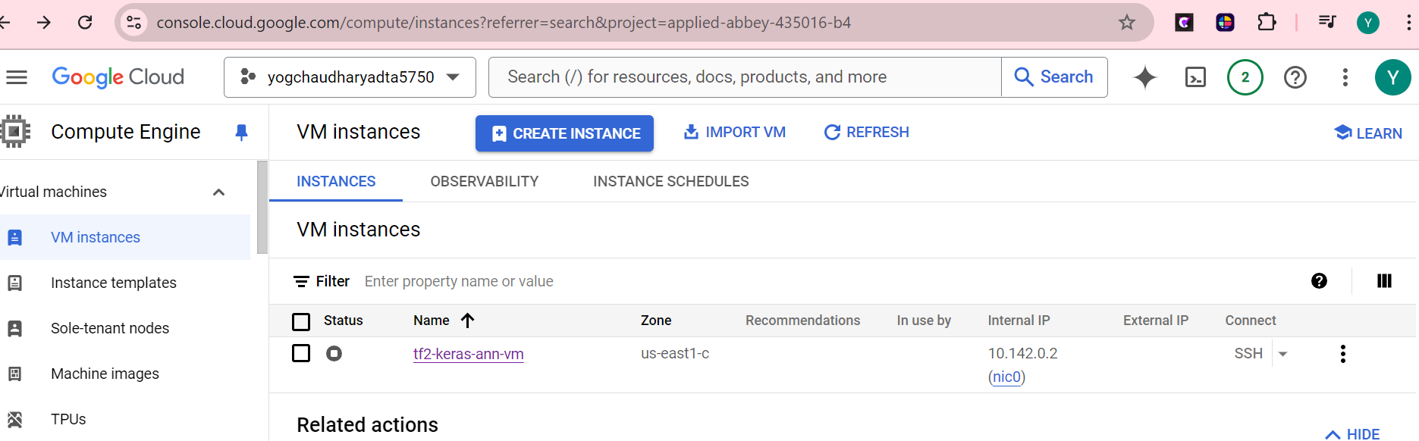

**6. PART VI: History of AI and Big Data (20 Points)**

* The start of AI: The history of Artificial Intelligence (AI)
* The periods in which AI seemed to be stalled for many years and WHY?
* The recent significant achievements, especially in the deep learning area, and the role of Big Data.

The human foundation of Artificial Intelligence (AI) records or traces the development and system designed to perform tasks, which can typically require intelligence. I went back to the mid-20th century, inspired by the development of the digital computer. Those ideas were to created machine learning and acting like humans. Those included problem-solving, decision -making, understanding language and recognizing, period of patterns the recent research by the deep learning and Big Data.

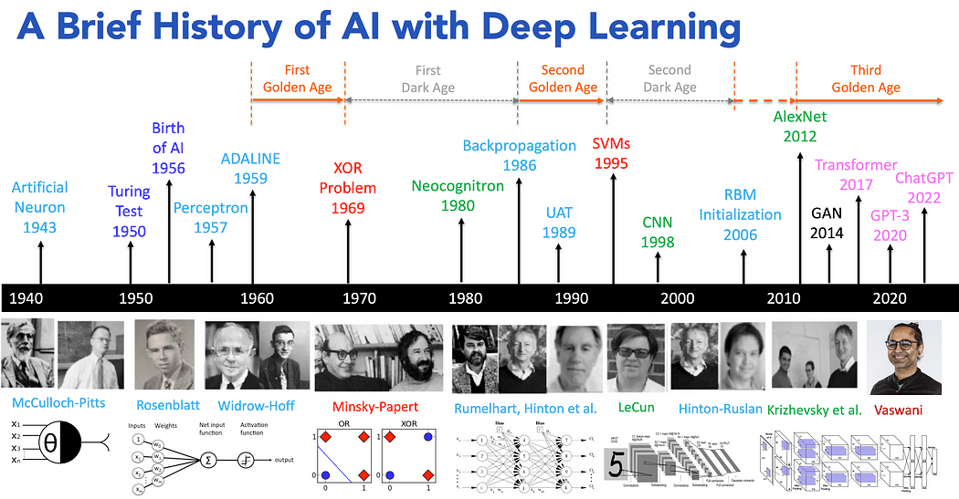

**The Dawn Of AI: 1940 S Until**

* 1943 - Neural Networks: Warren McCulloch and Walter Pitts published the first mathematical model for a neural network.
* 1950 - Turing Test: Alan Turing proposed the idea of testing a machine's ability to exhibit human-like intelligence through the Turing Test.
* 1956 - Dartmouth Conference: Considered the "birth of AI," this conference, organized by John McCarthy, established AI as a formal research field.

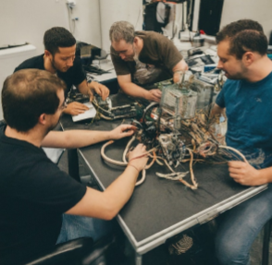

**The Winter: 1960S and 70s**

* Limited computational power: Early computers lacked the processing capabilities to handle complex AI algorithms.
* Overly optimistic expectations: Initial breakthroughs led to unrealistic expectations, which couldn't be met, resulting in funding cuts and decreased interest.
* Knowledge-based AI limitations: The focus on symbolic reasoning and logic proved insufficient for real-world tasks requiring adaptation and learning.
* The Rekindled Flame: The 1980s and 90s
* Expert systems gain traction: Knowledge-based systems designed for specific tasks like medical diagnosis show promise.
* Machine learning algorithms advance: Neural networks and decision trees see improvements, leading to applications in pattern recognition and game playing.
* A landmark victory: IBM's Deep Blue defeats chess grandmaster Garry Kasparov in 1997, showcasing the potential of AI.

**Machine Learning and Deep Learning (1990s - Present)**

AI resources were advances in machine learning and the development of deep learning algorithms are following.

* **Deep Learning:** Deep learning, introduced in the 2000s by researchers like Geoffrey Hinton, utilized multi-layered neural networks to enable machines to learn complex data patterns, revolutionizing fields such as image and speech recognition.
* **Breakthroughs in neural networks:** The development of efficient training algorithms like backpropagation and the availability of Big Data propel Deep Learning.
* **mage recognition leaps forward:** Deep neural networks achieve superhuman performance on image classification tasks.
* **AI goes mainstream:** Applications in natural language processing, robotics, and self-driving cars emerge, transforming various industries.

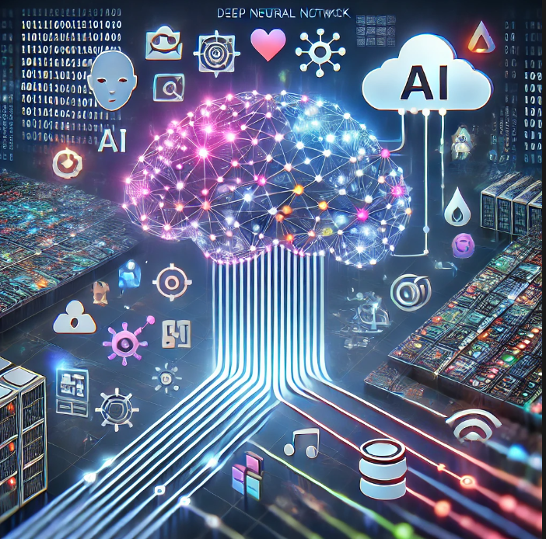

* Hare AI Power by deep learning a big data. They are multi-layer neural network processing large streams of data, with cloud computing infrastructure in the background supporting applications like image recognition, speech understanding, and natural language processing. Those help to visualize the massive computing power and data required for contemporary AI throughout deep learning process information to generate real-world solutions.

**The Role of Big Data**

* **Fueling Deep Learning:** The vast amount of data available allows neural networks to learn complex patterns and improve their performance.
* **Challenges and considerations:** Issues like data privacy, bias, and explainability need to be addressed as AI becomes more integrated into society.

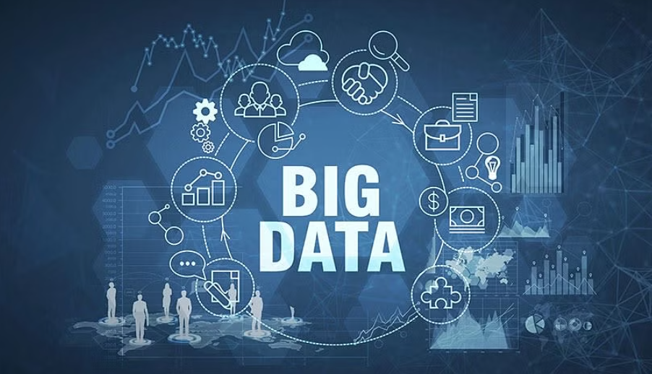

**The Futures of AI:**

The future of AI will be combination or multiple approaches, combining deep learning with symbolic AI, reinforcement learning AI. They will address current limitations, such as interpretability and computational demands, leading to more efficient and versatile systems. Advancements in Large Language Models, generative AI models. The future hold immense protentional for AI to improve our lives in various aspects, from healthcare and education to transportation sustainability, would be continuing to drive innovation, enhancing human-AI collaboration and creativity, while ensuring AI evolves in a balanced and beneficial way for all society.

**7. HOWTO Submit**

The student must submit all the sections, i.e., submission requirements, in a Microsoft Word document sent to the instructor (**Thuan.Nguyen@unt.edu** ) as an attachment to a UNT email.

The subject of the email must be: “**ADTA 5560: Assignment 1 – Submission**.”

**References**

LM Po, A Brief History of AI with Deep Learning Aug 31, 2024, Link- <https://medium.com/@lmpo/a-brief-history-of-ai-with-deep-learning-26f7948bc87b>

<https://www.simplilearn.com/how-big-data-can-influence-decision-making-article>

<https://www.kaggle.com/learn/intro-to-programming>

<https://www.cloudskillsboost.google/course_templates/536/video/500791>